Lesson 4 Report
Insecure Cloud Configuration
Abdulaziz Alwarthan
Student ID: 202160310

Brief Introduction
Lesson 4 focuses on an insecure cloud configuration in the DVSA application. The vulnerable component is the Amazon S3 feedback bucket dvsa-feedback-bucket-530467655445-us-east-1. The original configuration allowed public users to upload, read, delete, and modify object permissions. This is dangerous because an attacker can upload malicious or unexpected files into the application storage without proper authorization. The intended behavior is that normal users should only submit allowed feedback files, while administrators should keep full control over the bucket. In addition the users are limited only to upload txt files as an example of limitation

Affected Component
S3 Bucket: dvsa-feedback-bucket-530467655445-us-east-1 or buckets in general but most affected is this one

Main Security Issue
The bucket policy used a public principal and granted excessive permissions to everyone. This violates least privilege and exposes the bucket to unauthorized upload, read, delete, and ACL modification operations.

Evidence and Explanation

Screenshot 1 - Original bucket policy with public access
The original bucket policy contains PublicWritefeedbackStatement with Principal: *. This means the permission applies to everyone. The policy allows s3:PutObject, s3:PutObjectAcl, s3:GetObject, and s3:DeleteObject. This is the core insecure cloud configuration because public users receive more permissions than required.
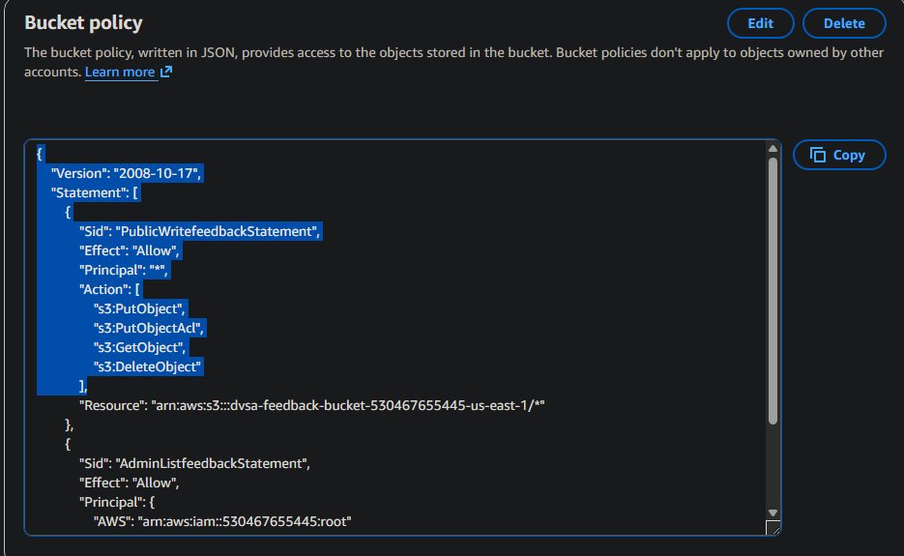
Screenshot 1 - Original bucket policy with public access

Screenshot 2 - Block Public Access disabled
The Block Public Access settings were disabled. This allowed the public bucket policy to take effect. Since AWS was not blocking public policies or public ACL behavior, the bucket remained exposed.
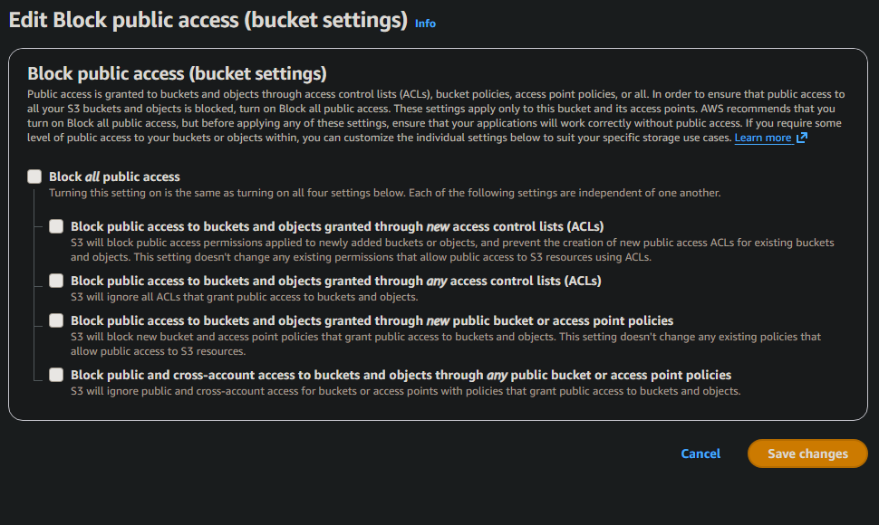
Screenshot 2 - Block Public Access disabled

As security Administrator I do not want to block the public access since it is only a temporary solution not root solution so by work throw the report you will find out why I prefer not to block the public access

Screenshot 3 - How an attacker can discover the bucket URL
The bucket URL is not secret. Attackers can discover it through JavaScript code, browser developer tools, network traffic, or predictable bucket naming. Security should not depend on hiding the bucket name.
#note: Explained by Ai to just show how the Attacker will work on this exploit
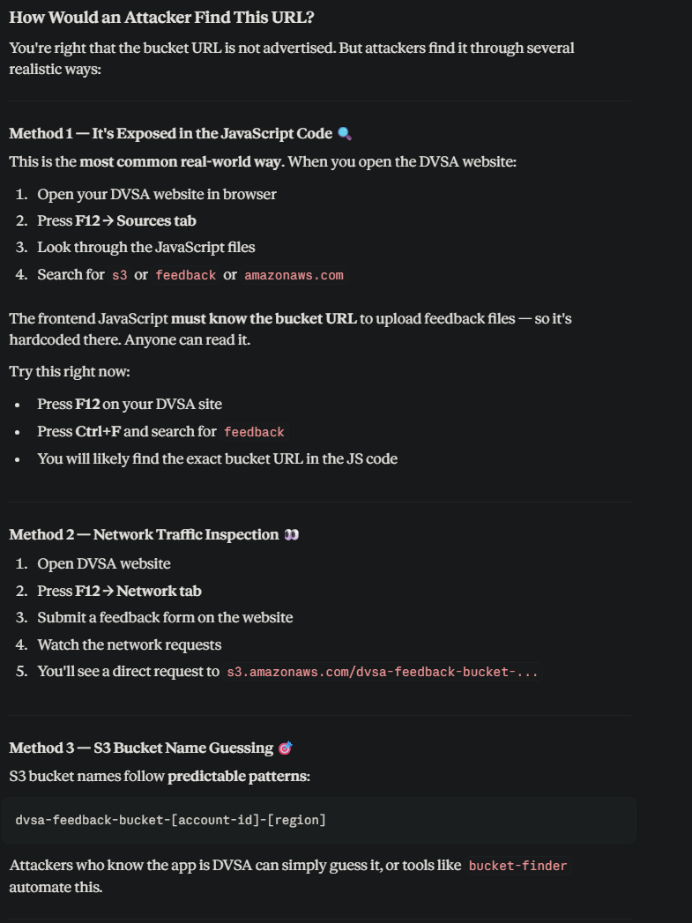
Screenshot 3 - How an attacker can discover the bucket URL

Screenshot 4 - Feedback references exposed in bundle.js
Browser developer tools were used to inspect bundle.js. The frontend code exposes feedback-related logic, proving that an attacker can understand the upload workflow from the client side.
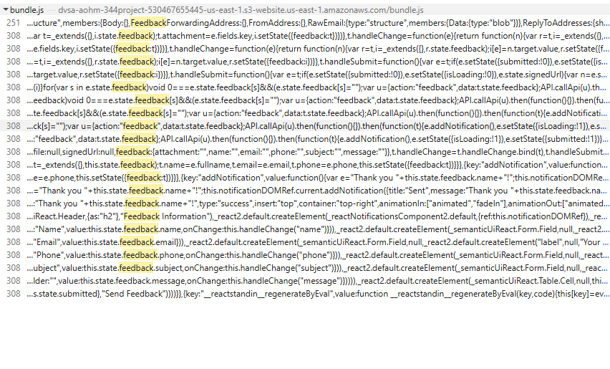
Screenshot 4 - Feedback references exposed in bundle.js

Screenshot 5 - DVSA feedback page
This is the normal DVSA feedback page. Users can enter feedback information and attach a file. If the storage policy and backend validation are weak, this normal feature can be abused.
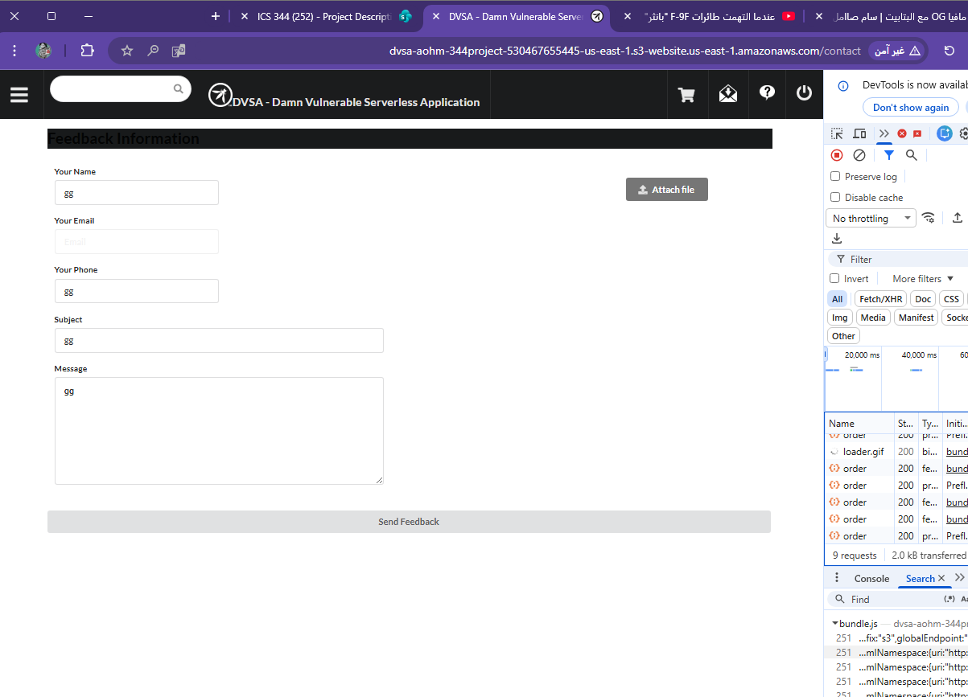
Screenshot 5 - DVSA feedback page

Screenshot 6 - Network activity during feedback upload
The Network tab shows feedback-related requests. This confirms that the upload workflow can be observed using ordinary browser tools.
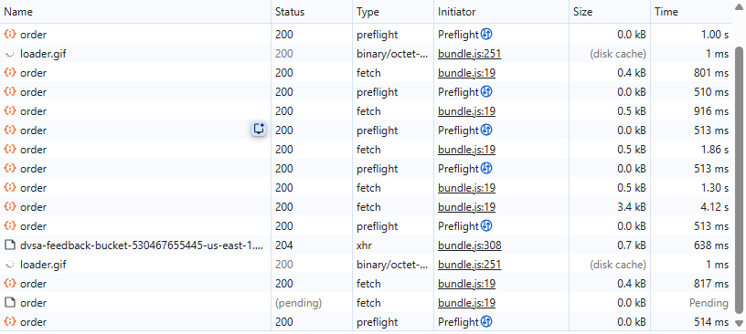
Screenshot 6 - Network activity during feedback upload

Screenshot 7 - Unauthenticated upload using AWS CLI
The command used aws s3 cp with --no-sign-request to upload malicious.html without AWS credentials. The upload succeeded before the fix, proving that unauthenticated public upload was possible.
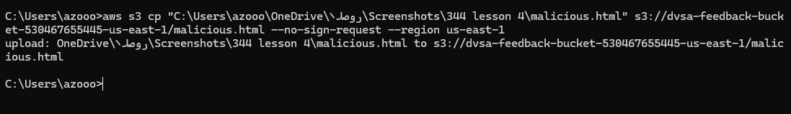
Screenshot 7 - Unauthenticated upload using AWS CLI

Screenshot 8 - malicious.html appears in the S3 bucket
The S3 object list shows malicious.html inside the feedback bucket. This confirms that the public upload succeeded and the object was stored in the application bucket.
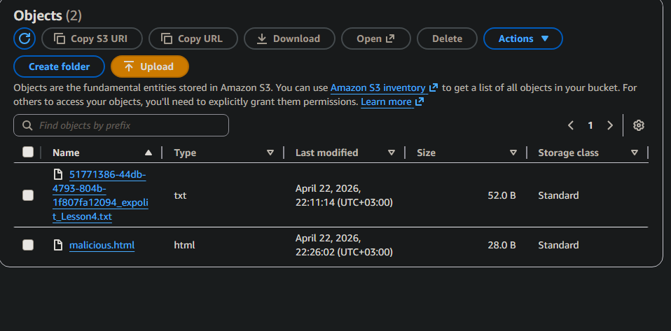
Screenshot 8 - malicious.html appears in the S3 bucket

Screenshot 9 - malicious.html opened in browser
The uploaded HTML file was accessed directly from the browser and displayed HACKED-Insecure-S3-Config. This proves that the uploaded object was publicly readable from the internet.
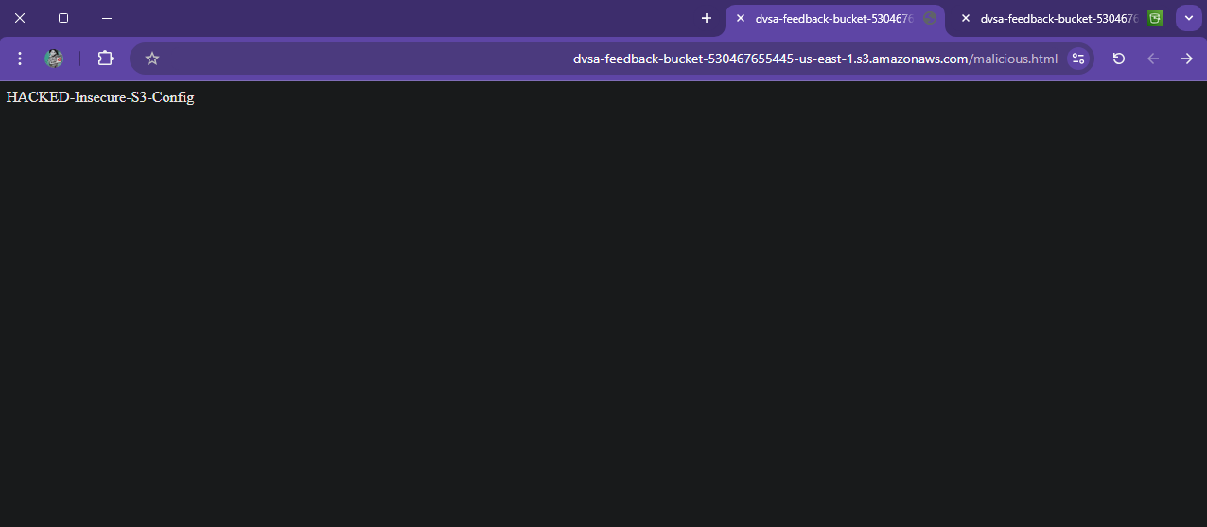
Screenshot 9 - malicious.html opened in browser

Screenshot 10 - Unauthenticated download using AWS CLI
The malicious file was downloaded using AWS CLI with --no-sign-request. This proves that public read access was allowed before the fix.
Screenshot 10 - Unauthenticated download using AWS CLI

Screenshot 11 - Block Public Access enabled
Block Public Access was enabled as part of the hardening step. This helps prevent future public bucket policies and public ACLs from exposing the bucket again. Just enabled to handle the security issue not as solution so I disabled it later
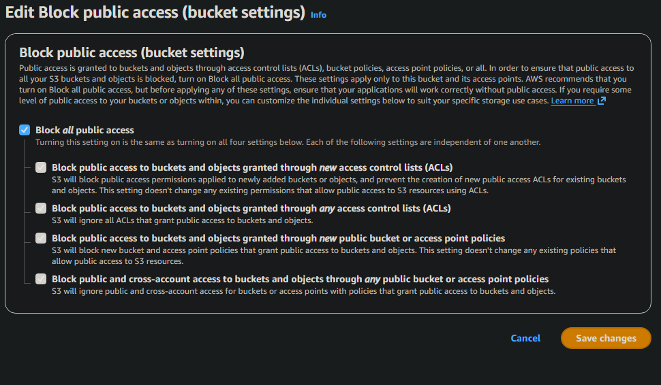
Screenshot 11 - Block Public Access enabled

Screenshot 12 - Updated bucket policy and update the Functionality of the service (optional and explained why in the Videos)
The updated bucket policy limits access to the AWS account root/admin principal. The public principal was removed, so anonymous users no longer receive direct S3 permissions.
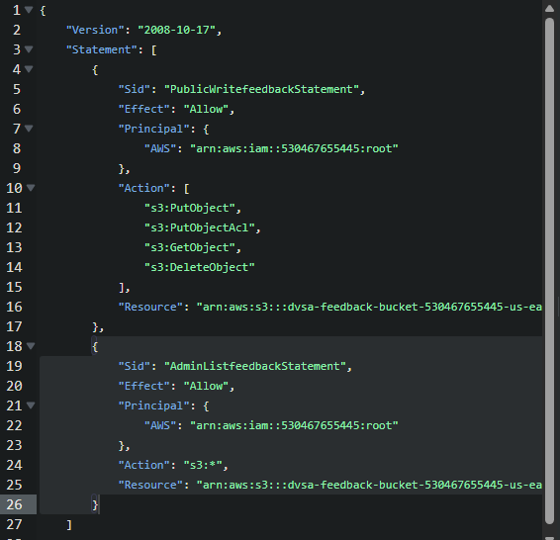

Screenshot 12 - Updated bucket policy
Updating the Feedback_uploads.py and add only if statement to prevent other files than txt files to get uploaded from the users. -this is well explained in the videos of the lesson-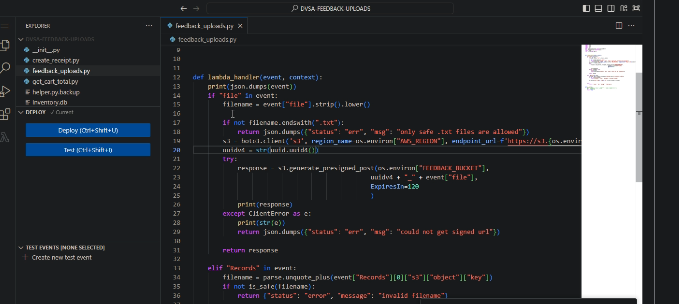

Screenshot 13 - Upload denied after fix
The same unauthenticated upload test was repeated after the fix. The command returned AccessDenied, proving that public users can no longer upload files to the bucket.
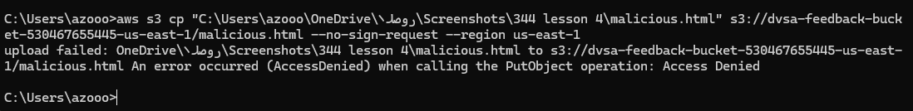
Screenshot 13 - Upload denied after fix

Screenshot 14 - Browser access denied after fix
Opening the malicious file URL after the fix returned AccessDenied. The anonymous user is no longer authorized to perform s3:GetObject. NOT THE BROWESER ONLY THE FILES THAT HAS BEEN SECURED FROM PUBLIC ACCESS SO THE USER STILL CAN USE THE BROWSER
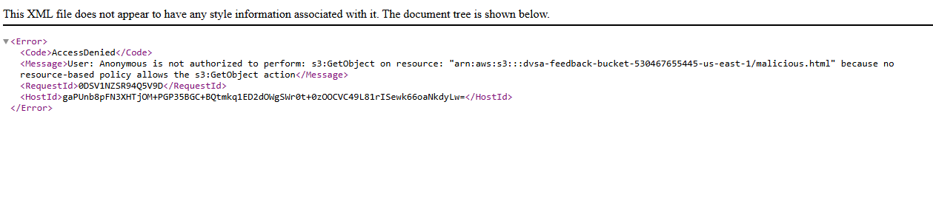
Screenshot 14 - Browser access denied after fix

Screenshot 15 - Public CLI access denied while admin still sees objects
The CLI test shows 403 Forbidden when attempting unauthenticated access, while the AWS Console still shows the objects to the administrator. This proves that public access was blocked while admin access remained working.
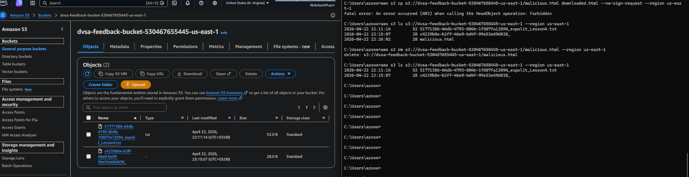
Screenshot 15 - Public CLI access denied while admin still sees objects

Root Cause
The root cause was an insecure S3 bucket policy combined with disabled Block Public Access. The policy used Principal: * and allowed public users to perform sensitive S3 actions such as PutObject, PutObjectAcl, GetObject, and DeleteObject. This granted unauthenticated users excessive access to the feedback bucket.

Impact
An attacker could upload malicious or unwanted files, host HTML content inside the application bucket, read uploaded files, delete objects, and modify object permissions. This creates risk of data exposure, malicious file hosting, content injection, and abuse of cloud resources.

Fix Applied
The bucket was hardened by enabling Block Public Access and changing the bucket policy so public users no longer have upload, read, delete, or ACL permissions. Administrative access was preserved for the AWS account owner, allowing the bucket to remain manageable by authorized users.

Verification After Fix
After the fix, the same unauthenticated upload and download tests were repeated using AWS CLI with --no-sign-request. The upload returned AccessDenied and the download returned 403 Forbidden. Browser access to the malicious file also returned AccessDenied. This confirms that public access was successfully removed while administrator access remained available through the AWS Console.

Before and After Summary
Test | Before Fix | After Fix
Public upload using --no-sign-request | Succeeded | AccessDenied(only txt file as example for limitation)
Public browser access to malicious.html | Succeeded | AccessDenied
Public download using --no-sign-request | Succeeded | 403 Forbidden
Admin access through AWS Console | Worked | Still works

Conclusion
Lesson 4 demonstrated an insecure cloud configuration in the DVSA feedback S3 bucket. The original bucket policy granted public users excessive permissions, allowing unauthenticated upload, read, delete, and ACL modification. The vulnerability was proven by uploading and accessing malicious.html without AWS credentials. After applying the fix, public upload and public read access were denied, while admin access remained available. This confirms that the S3 bucket was successfully hardened.

